FAFSA Business Manual

Training Guide for Businesses to Assist Employees with FAFSA and

Host a Community FAFSA Assistance Night

Introduction
The Free Application for Federal Student Aid (FAFSA) is a crucial step for students to receive financial aid for college or career school. As businesses can play a key role in supporting their employees’ education goals, it’s important for employers to help their staff understand and navigate the FAFSA process. This training guide will prepare your employees to assist others in completing the FAFSA and hosting a successful community FAFSA Assistance Night.

Goals of the Training:
- Understand the importance of FAFSA.
- Know how to complete the FAFSA for the 2025-2026 academic year.
- Learn how to help others with FAFSA during a community FAFSA Assistance Night.
- Gain confidence in assisting employees and community members with FAFSA-related questions.

Module 1: Introduction to FAFSA

Objective: To understand the basics of the FAFSA, why it's important, and how it supports students in securing financial aid for higher education.

Key Topics:
- What is FAFSA?
  - The FAFSA is the federal application form that determines a student's eligibility for financial aid (federal grants, loans, and work-study programs).
  - It is required for most colleges and universities to award institutional and federal financial aid.
- Who Needs to Fill Out FAFSA?
  - All U.S. citizens or eligible non-citizens applying for federal student aid.
  - Both dependent and independent students.
- Why FAFSA Matters
  - Provides access to billions of dollars in financial aid.
  - Opens doors to federal and state grants, work-study, and student loans.
  - Schools use FAFSA data to offer merit-based scholarships.

Resources:
- NCAN's Overview of FAFSA
- Federal Student Aid (FSA) Overview Video

Module 2: FAFSA for the 2025-2026 Application Year

Objective: To understand the updates and process of filling out the FAFSA for the 2025-2026 academic year.

Key Topics:
- Important Changes for the 2025-2026 FAFSA:
  - Simplification of the FAFSA form: A streamlined application process, making it easier for students and families to complete.
  - Use of the IRS Data Retrieval Tool (DRT): For faster and more accurate reporting of financial data.
  - Removal of Expected Family Contribution (EFC): Replaced with the Student Aid Index (SAI), which helps to determine eligibility for federal student aid.
- The FAFSA Application Process:
  - Create a FSA ID: Both the student and a parent (if applicable) need an FSA ID to sign the FAFSA electronically.
  - Gather Necessary Documents:
    - Social Security Number (SSN) or Alien Registration Number (if not a U.S. citizen).
    - 2023 Tax Return for the student and parent (if applicable).
    - W-2 forms and other records of income.
    - Bank and investment information.
  - Complete the FAFSA: Follow the steps on the official website to complete the application.

Step-by-Step Video for Completing FAFSA:
- FAFSA Video – How to Fill Out the FAFSA

Module 3: Common FAFSA Errors and How to Avoid Them

Objective: To understand common FAFSA mistakes and how to ensure accuracy when filling out the application.

Key Topics:
- Common FAFSA Mistakes:
  - Incorrect Social Security Numbers.
  - Missing or incorrect parental financial information.
  - Not selecting the right college or university.
  - Errors in answering dependency questions.
- How to Avoid These Mistakes:
  - Double-check the information before submitting.
  - Use the IRS Data Retrieval Tool to transfer tax information.
  - Read all questions carefully to avoid misunderstanding.

Helpful Information on Common FAFSA Mistakes:
- FSA Tips & Common Mistakes to Avoid

Module 4: Hosting a FAFSA Assistance Night

Objective: To prepare employees to host a successful community FAFSA Assistance Night, offering support and guidance to local students and families.

Key Topics:
- Planning the Event:
  - Choose a Convenient Date and Location: Ensure the event is accessible to the target community (e.g., school parking lots, local libraries, community centers).
  - Promote the Event: Use flyers, emails, and social media to inform the community. Leverage partnerships with local schools and organizations.
  - Provide Necessary Resources: Have computers or devices with internet access. Ensure volunteers are equipped with the knowledge and tools needed (like access to FSA resources and handouts).
- Staff Training for the Event:
  - Familiarize with the FAFSA: Review the latest 2025-2026 FAFSA changes and ensure volunteers are up to date with the process.
  - Provide One-on-One Support: Guide students and families in completing their FAFSA applications, troubleshoot technical issues, and answer common questions.
- Key Tips for Assisting Others:
  - Be patient and clear in your explanations.
  - Offer support for gathering the required documentation.
  - Direct families to resources for additional help, such as FAFSA help desks or financial aid offices.

Preparation Resources:
- FSA – FAFSA Assistance Night Toolkit
- How to Host a FAFSA Assistance Event

Module 5: Questions and Answers

Objective: To address any common questions employees may have regarding the FAFSA and the community event.

Key Topics:

What happens if I make a mistake on the FAFSA?
- Answer: If you realize that you've made a mistake on your FAFSA after submitting it, you can log into your account and correct the information. For most errors, you can simply update the information online, and the system will automatically adjust your application. You may also need to provide additional documentation if the mistake is related to income or other key details. If a correction is required after submission, your financial aid office may follow up with you to ensure all information is accurate before finalizing your aid package.

2. How do I check the status of my FAFSA?
- Answer: To check the status of your FAFSA, log into your Federal Student Aid (FSA) account at studentaid.gov. From there, you can see the status of your application, including whether it's been processed, if there are any issues, or if additional steps are required. You will also receive a Student Aid Report (SAR) summarizing your application information, and you can review the SAR for any discrepancies or further action needed.

3. What if my parents don’t have a Social Security number?
Make sure to carefully review which application is right for you based on your citizenship status
and residency in Washington State. If you are unsure, your school's financial aid office or
local support organizations can provide guidance on which application to complete.
- If you choose to complete the FAFSA and your parent does not have a social security number:
  - Use “000-00-0000” for the Parent’s SSN: If the parent is undocumented and does not have a Social Security Number (SSN), you should enter “000-00-0000” is the SSN field of the FAFSA.
  - Student’s Eligibility for Federal Aid:
    - The student will still be eligible for federal financial aid (Pell Grants, federal loans, and work-study) if the student is a U.S. citizen, legal permanent resident, or eligible non-citizen.
    - The lack of a parent's SSN will not prevent the student from receiving federal aid, if the student meets the necessary eligibility requirements.

- Washington State Aid:
  - In Washington, students in mixed-status families may be eligible for the Washington College Grant if their parent does not have an SSN. Washington State also provides specific support for undocumented students through the WA Dream Act.
  - If you are an undocumented student (or if your parents are undocumented), you may qualify for Washington State Aid by completing the Washington Application for State Financial Aid (WASFA) instead of the FAFSA.
    - The WASFA is for people who choose not to file a federal FAFSA application.
    - If you have completed the FAFSA, you have already applied for federal and state financial aid and do not need to complete the WASFA unless your college asks you to.
- The WASFA Process: If the student is an undocumented Washington State resident, they should complete the WASFA instead of the FAFSA. The WASFA is used to apply for state-funded financial aid, such as the Washington College Grant, Washington State Need Grant, and other state scholarships. WASFA applicants do not need to provide a parent’s SSN.
  - Federal Aid (FAFSA): The student’s eligibility for federal financial aid will not be impacted by the parent’s undocumented status.
  - State Aid (WASFA): If you are applying through WASFA, the application will not ask for a parent’s SSN. However, it may ask for other financial information from the parent (e.g., income, taxes). If the parent cannot provide tax information, the student can still apply but may need to submit alternative documentation through the Washington State financial aid office for verification.
- Alternative Documentation for Mixed-Status Families: If your parent is unable or unwilling to provide their SSN, you may still be able to complete the FAFSA or WASFA with alternative documentation.

If you’re unsure how to handle mixed-status family situations and documentation, seek additional advice from your school counselors or trusted local support organizations.

Resources for Washington State Students:
- Washington State Financial Aid:
  - FAFSA and WASFA Information: Washington State Financial Aid Portal
  - Washington College Grant (WCG) and State Need Grant (SNG): Apply for State Financial Aid in Washington
- For Undocumented Students:
  - WA Dream Act (WASFA): WASFA Application Portal
  - Washington State Association of Colleges and Employers (WSACE) Resource for Dreamers: Resource for Dreamers in Washington
- NCAN (National College Attainment Network) - Mixed Status Families:
  - NCAN Resource Page for Mixed-Status Families
- Local Support Organizations:
  - College Success Foundation (CSF) Washington: Offers resources for Washington students, including undocumented students.

4. How do I get help with FAFSA if I don’t have access to a computer?
- Answer: If you do not have access to a computer, there are still ways to complete your FAFSA:
  - Local Libraries or Community Centers: Many libraries and community centers provide free computer access. You can visit these locations to complete the FAFSA online.
  - Financial Aid Offices: Some colleges and universities offer assistance with completing the FAFSA. You can also check with local non-profit organizations or high school counseling offices to see if they provide resources.
  - Call the FAFSA Help Line: You can contact the Federal Student Aid (FSA) Help Center at 1-800-4-FED-AID (1-800-433-3243) to get assistance over the phone. They can guide you through the process.

5. How do I get help with FAFSA if I need special accommodations?
- Answer: If you need special accommodations due to a disability or other reasons, the FSA website provides accessibility features to support various needs. You can also contact the Federal Student Aid (FSA) Help Center directly to request accommodations. Additionally, many local community centers or advocacy groups can assist with navigating the FAFSA application with accommodations.

6. What if I miss the FAFSA deadline?
- Answer: If you miss the FAFSA deadline, you may still be able to receive some financial aid, but your eligibility may be reduced. Many states and colleges have priority deadlines for FAFSA submission, and federal aid will be awarded on a first-come, first-served basis. It’s best to submit your FAFSA as early as possible. If you've missed a deadline, contact your school’s financial aid office as soon as possible to explore your options.

7. What if I don’t know my parents’ tax information?
- Answer: If you don't have access to your parent's tax information, you can still submit the FAFSA using estimated figures. However, you'll need to update the FAFSA with the correct figures as soon as possible once you get the correct information. If your parents are unable or unwilling to provide the required details, you may be eligible for a "dependency override" through your college’s financial aid office. This could allow you to file as an independent student, though this is a rare and specific situation.

8. What happens after I submit my FAFSA?
- Answer: After you submit your FAFSA, you will receive a Student Aid Report (SAR) that summarizes your application data. The SAR will include your Expected Family Contribution (EFC), which helps determine your eligibility for federal student aid. Schools you list on the FAFSA will use this information to create your financial aid package. If there are any errors or additional steps needed (such as submitting tax documents), you will be notified via email or on your FAFSA portal.

9. How can I find out what financial aid I am eligible for?
- Answer: After submitting your FAFSA, you will receive a Student Aid Report (SAR) with your Expected Family Contribution (EFC). Your EFC helps determine the types and amount of financial aid you may be eligible for, including federal grants, work-study programs, and loans. Your chosen schools will also send you an award letter detailing the specific financial aid you are being offered based on the information from your FAFSA.

10. What should I do if my FAFSA is selected for verification?
- Answer: If your FAFSA is selected for verification, the school will ask you to provide additional documentation to verify the accuracy of the information you provided. This could include tax returns, W-2 forms, and other financial documents. It’s essential to respond promptly to any requests for verification so that your financial aid can be processed without delay.

Forms & Documents

Finding Money for College or Career School Presentation provided by Federal Student Aid (FSA)

Do You Need Money for College or Career/Trade School?

2025-2026 FAFSA Preview Presentation

Students With Unusual Circumstances

Templates for Events and Social Media Outreach (With LaunchNW Logo)
Different Scenereos Businesses Might Want to Host an Eevent or Info-Session
- Employee Benefits Info-Session/ Employee Training
- Community FAFSA Assistance Night (e.g., Providence FAFSA Assistance Night)
- Family FAFSA Assistance Night (for employees and their families/kids)

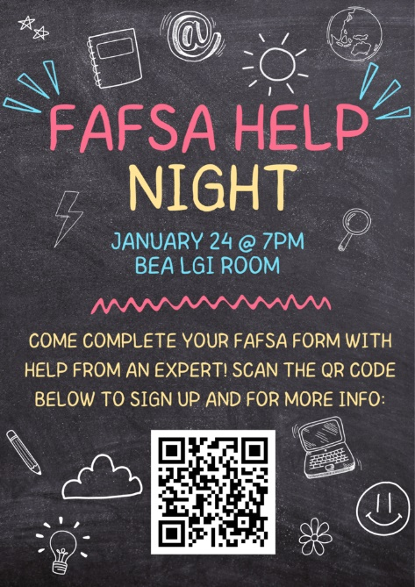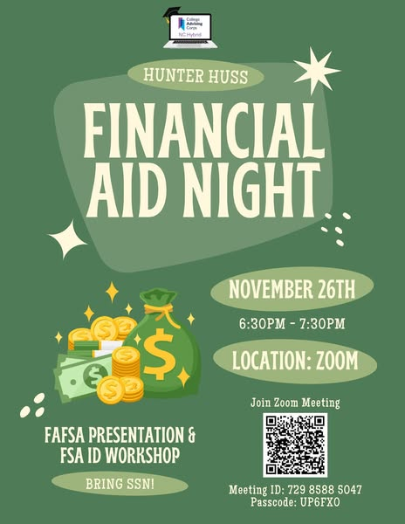

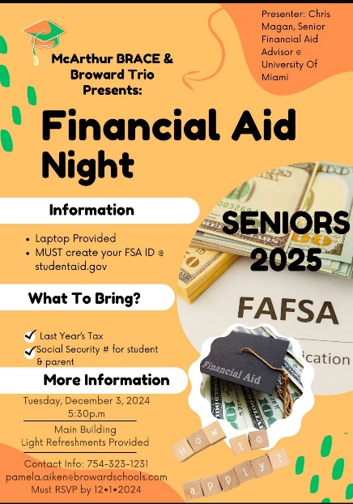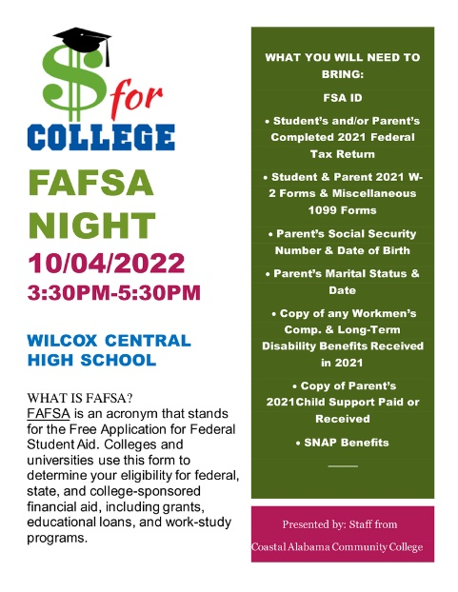

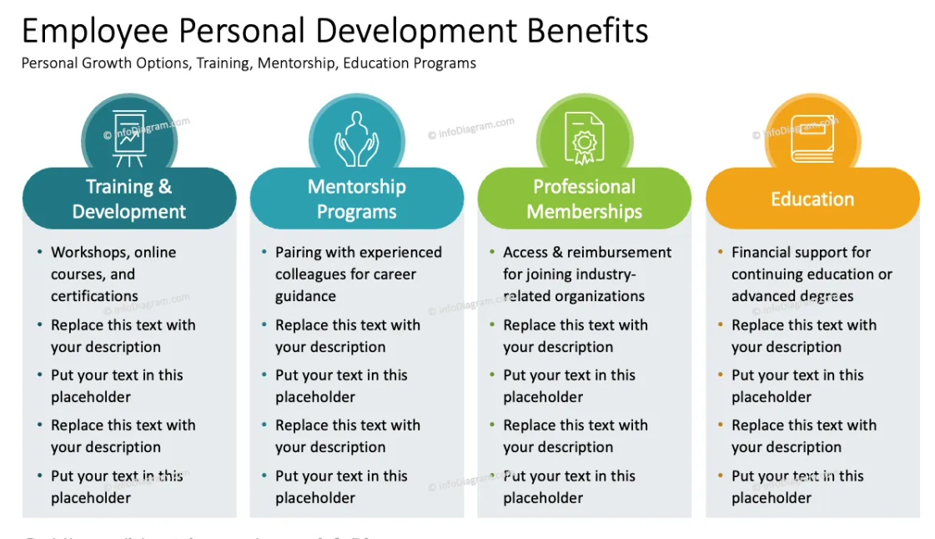
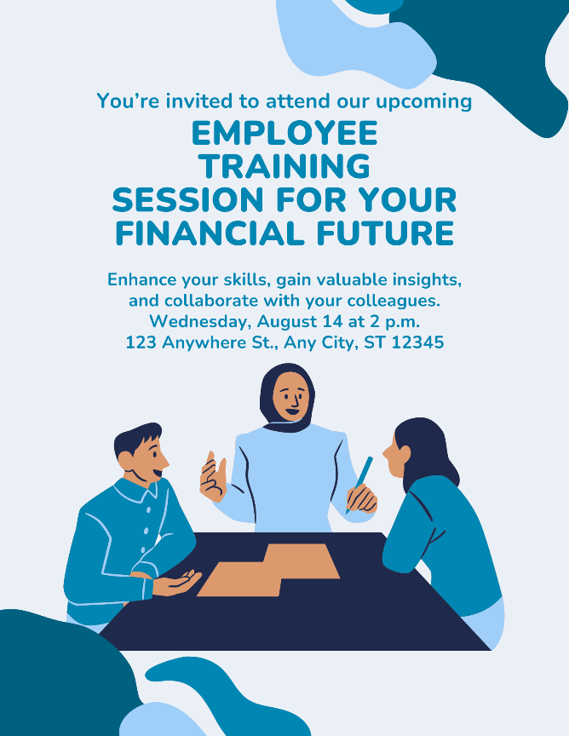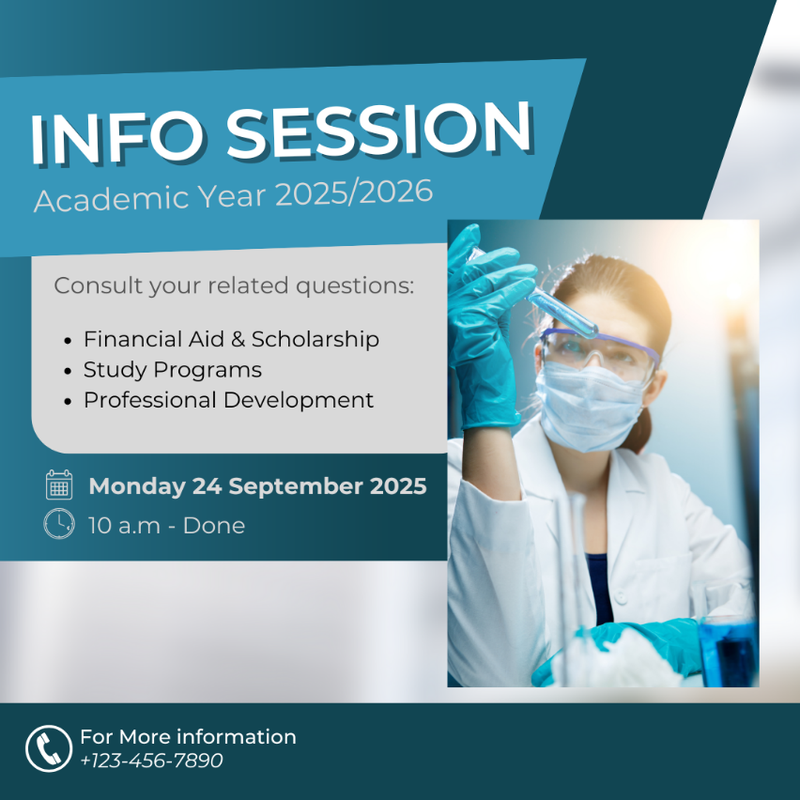

Conclusion
After completing this training guide, your employees will be better equipped to assist both themselves and their community with FAFSA-related questions and processes. Hosting a FAFSA Assistance Night will not only benefit employees but also create positive community engagement.

Additional Resources:
- Federal Student Aid (FSA) Website
- National College Attainment Network (NCAN)

Note: Be sure to check the official FSA website for any updates related to the FAFSA process for the 2025-2026 academic year, as changes may occur.

